

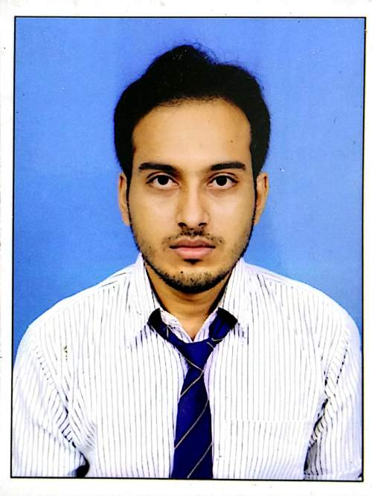

# 

[adak.sourav1995@gmail.com](mailto:adak.sourav1995@gmail.com)



+91-7687834556



VILL+POST- Jagatnagar

DIST-Hooghly

PIN-712409,

West Bengal, India

**PROGRAMMING LANGUAGE**

Python

R

Java

**SKILLS AND TOOLS**

Databricks

SQL

Apache Spark

PyTorch

POSTMAN

TensorFlow

Power BI

Power Apps

Power Automate

**Sourav Adak** Data Scientist

**EDUCATION**

**Indian Institute of Technology (IIT), Jodhpur** Data and Computational Science (M. Tech) 2021-2023 CGPA- 7.0

**Kalinga Institute of Industrial Technology** Electronics and Electrical Engineering (B. Tech) 2017-2020 CGPA- 7.68

**WORK EXPERIENCE**

**July 2022 – Present |Healthcare Company | Data Analyst**

* Assisted in the integration of Azure Databricks with other Azure services like Azure Blob Storage, Azure Data Factory, and Azure SQL Data Warehouse.
* Veeva Safety Vault application dataflow through different layers in Azure (Raw, Foundation, Enrich)
* Design Data pipeline configuration.
* Conducted advanced analytics on structured and unstructured data using PySpark and Databricks notebooks.

**Aug 2021 – July 2022 | Healthcare | Automation Tester**

* Worked with a team of 30+ members from different domains to deliver complete applications from scratch to Go Live.
* Test case Design, HP ALM, RTM, Reports Generation (Test Plan & Strategy, Test Cycle Index, Test Cycle Summary, Test Summary Report)
* Selenium using Java
* Tested and delivered different SharePoint M365 applications.

Tested Power Apps and Power Automate based Applications.

**Feb 2021 – July 2021 |Takeda| Manual Tester**

* Test Case design, Test Case Execution, Requirement understanding
* Agile Methodology
* Have experience in JIRA Tool

**Aug-2020- Jan 2021 |Trainee |Automation Tester**

* Functional Testing, Agile and Waterfall methodology
* Selenium WebDriver using Java
* Framework Design (Data Driven using TestNG, BDD Cucumber)
* API Testing using SoapUI tool and POSTMAN
* Core Java, SQL, HTML, CSS, JavaScript, XML, JSON